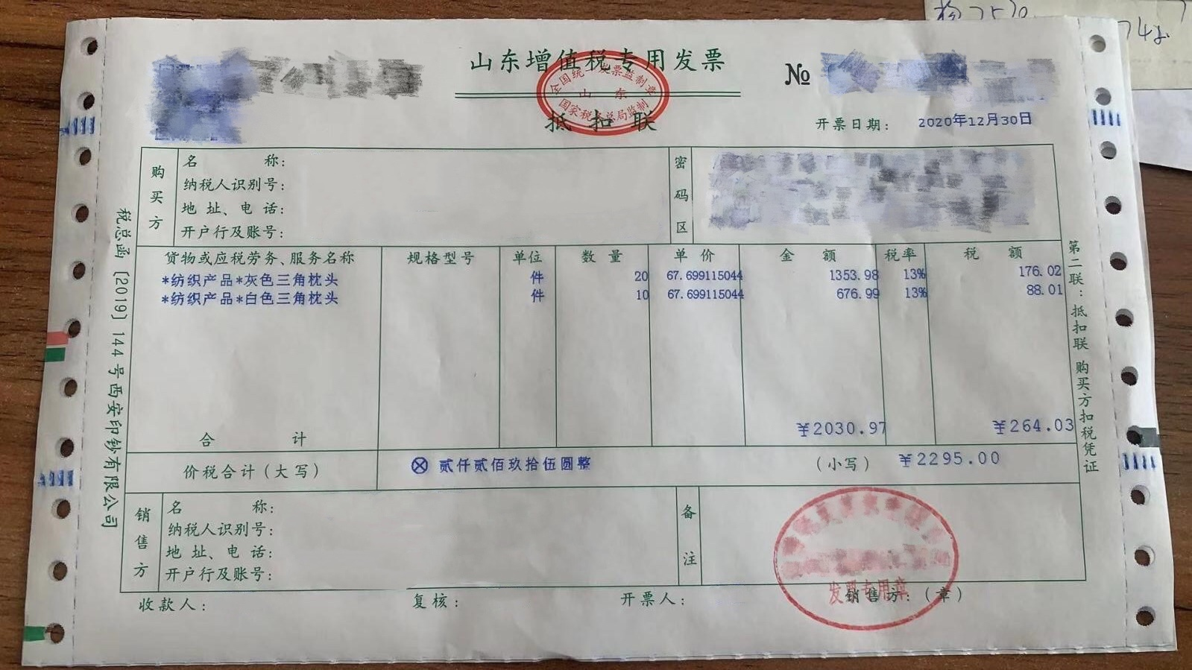
QR Code VAT Electronic General Invoice
Invoice code: xxxxxxx
Invoice number: xxxxxxx
Invoicing date: December 30, 2020
Check code:
Machinery code: National Unified Invoice Supervision Seal
State Administration of Taxation
Taxation Bureau

Buyer | Name: Company Name  Taxpayer identification number: xxxxxxx  Address and telephone number: Company Address  Account bank and account number: Band Name and Number |  |  |  | Password | XXX
Project name  XXXXX  Total |  | Specification model | Unit  piece | Quantity  XX | Unit price  XX |  | Amount  XX  ¥ | Tax rate  XX% | Tax amount  XX  ¥
Total price and tax (uppercase) |  | XXX (In English) (in figures)¥XX
Seller | Name: Company Name  Taxpayer identification number: xxxxxxx  Address and telephone number: Company Address  Bank and account number: Band Name and Number |  |  |  | Remark
Payee: Name Reviewed by: Name Invoiced by: Name Seller: (seal)
Company Name

注意：此为采购发票翻译填写样本，填写时应当删除文本中标黄红色字体部分,并结合您的实际情况进行填写，若有任何问题，请联系您的税务代理获取帮助。

